Diagnostic Analysis Report
Report Generated: May 12, 2026 | 05:10:17
____________________________________________________________

1. Analysis Executive Summary
Diagnostic Determination | BENIGN (NON-CANCEROUS)
Probability Coefficient | 0.2279
Confidence Level | 77.21%
Neural Network ID | FibonacciNet-v1 (Fib-DWSC)

2. Diagnostic Imaging & Interpretability

Primary Ultrasound Scan
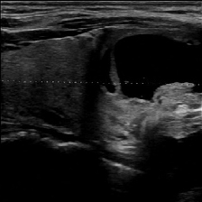

Grad-CAM Attention Heatmap
Warmer colours indicate regions that most strongly influenced the classification output.
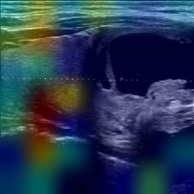

3. AI-Generated Clinical Narrative (Groq / LLaMA 3.1)
**Clinical Interpretation:**
A thyroid ultrasound image was evaluated using artificial intelligence (AI) for diagnostic purposes. The AI algorithm predicted a benign lesion with a confidence level of 22.86%. This result suggests that the AI has some degree of uncertainty regarding the nature of the lesion. Given the low confidence level, further clinical evaluation and correlation with clinical history, physical examination, and other diagnostic modalities (e.g., fine-needle aspiration biopsy) are recommended to confirm the diagnosis.

4. Technical Methodology
ThyroCheck AI employs FibonacciNet — a novel CNN with Fibonacci-scaled filter counts (21, 34, 55, 89, 144, 233, 377) and Partial Connection Blocks (PCB) for multi-scale feature extraction. Explainability is delivered via Gradient-weighted Class Activation Mapping (Grad-CAM) over the final DepthwiseSeparableConv layer.

----------------------------------------
IMPORTANT CLINICAL DISCLAIMER
This report is generated by an AI system for research purposes only and does NOT constitute a clinical diagnosis. All findings must be reviewed by a qualified radiologist or medical professional.

